Suppliers 1:

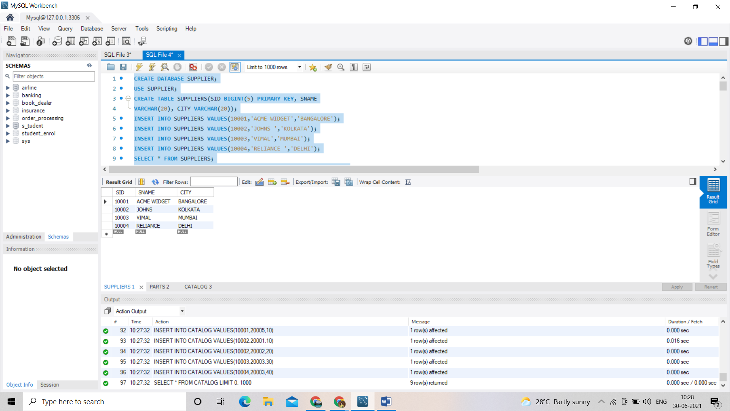

Parts 2:

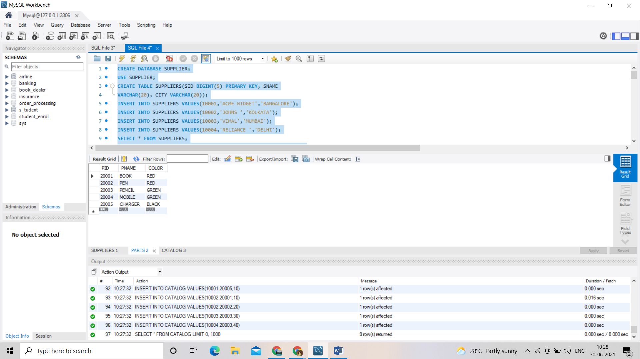

Catalog3:

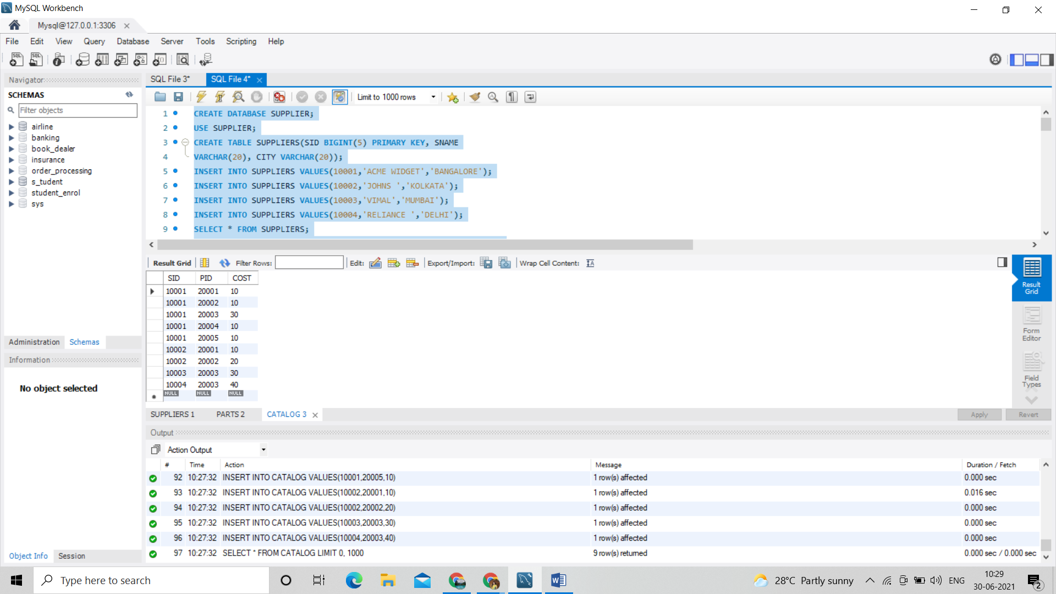

/\* 1 - FIND THE PNAMES OF PARTS FOR WHICH THERE IS SOME SUPPLIER. \*/

SELECT DISTINCT P.PNAME

FROM PARTS P, CATALOG C

WHERE P.PID = C.PID;

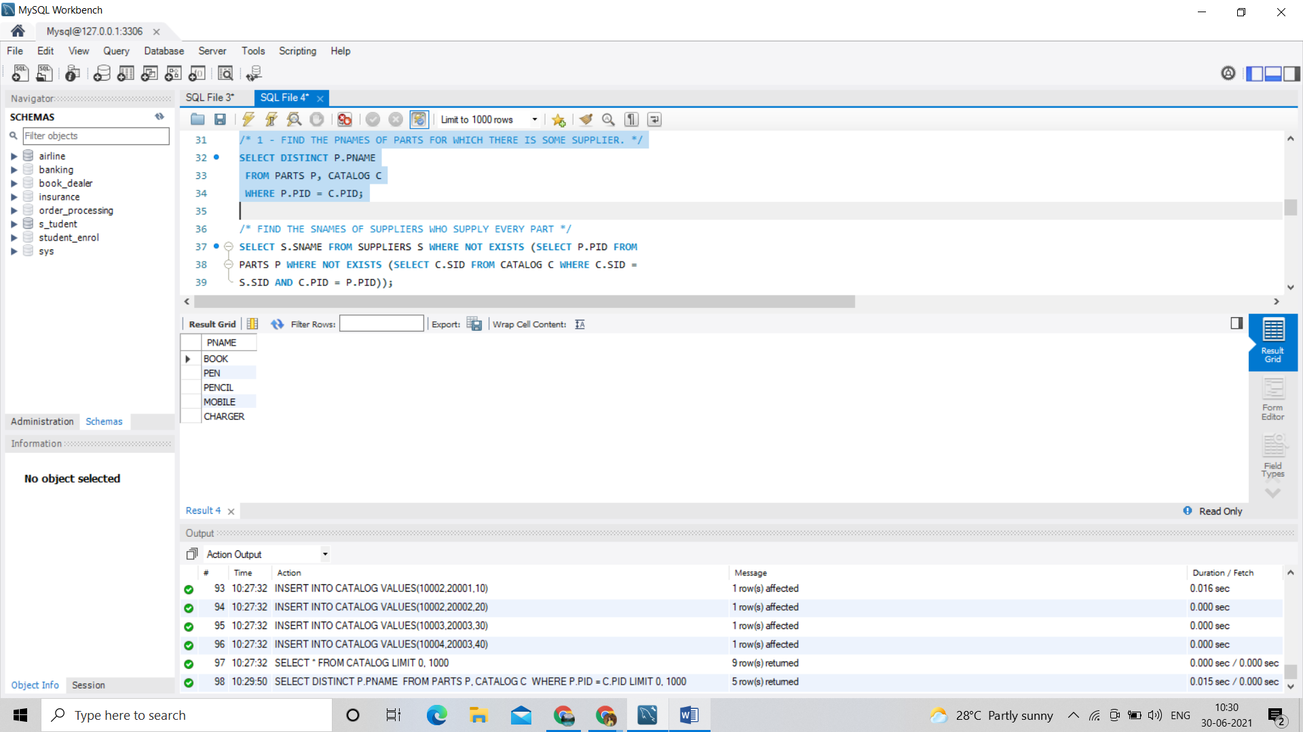

/\* 2.FIND THE SNAMES OF SUPPLIERS WHO SUPPLY EVERY PART \*/

SELECT S.SNAME FROM SUPPLIERS S WHERE NOT EXISTS (SELECT P.PID FROM

PARTS P WHERE NOT EXISTS (SELECT C.SID FROM CATALOG C WHERE C.SID =

S.SID AND C.PID = P.PID));

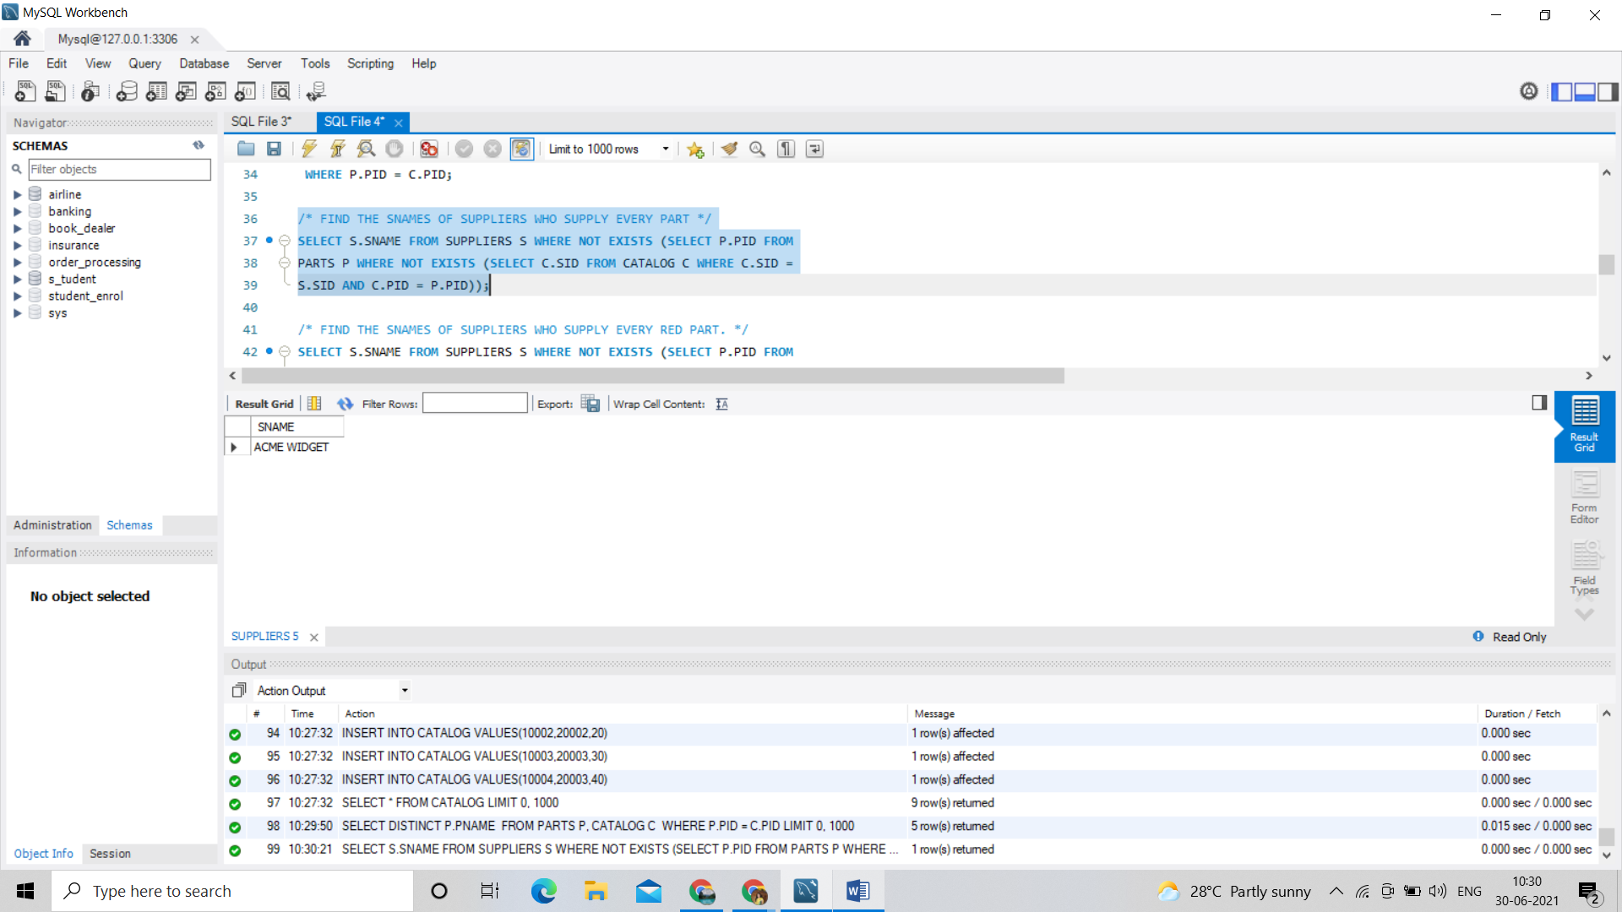

/\* 3.FIND THE SNAMES OF SUPPLIERS WHO SUPPLY EVERY RED PART. \*/

SELECT S.SNAME FROM SUPPLIERS S WHERE NOT EXISTS (SELECT P.PID FROM

PARTS P WHERE P.COLOR = 'RED' AND (NOT EXISTS (SELECT C.SID FROM

CATALOG C WHERE C.SID = S.SID AND C.PID = P.PID)));

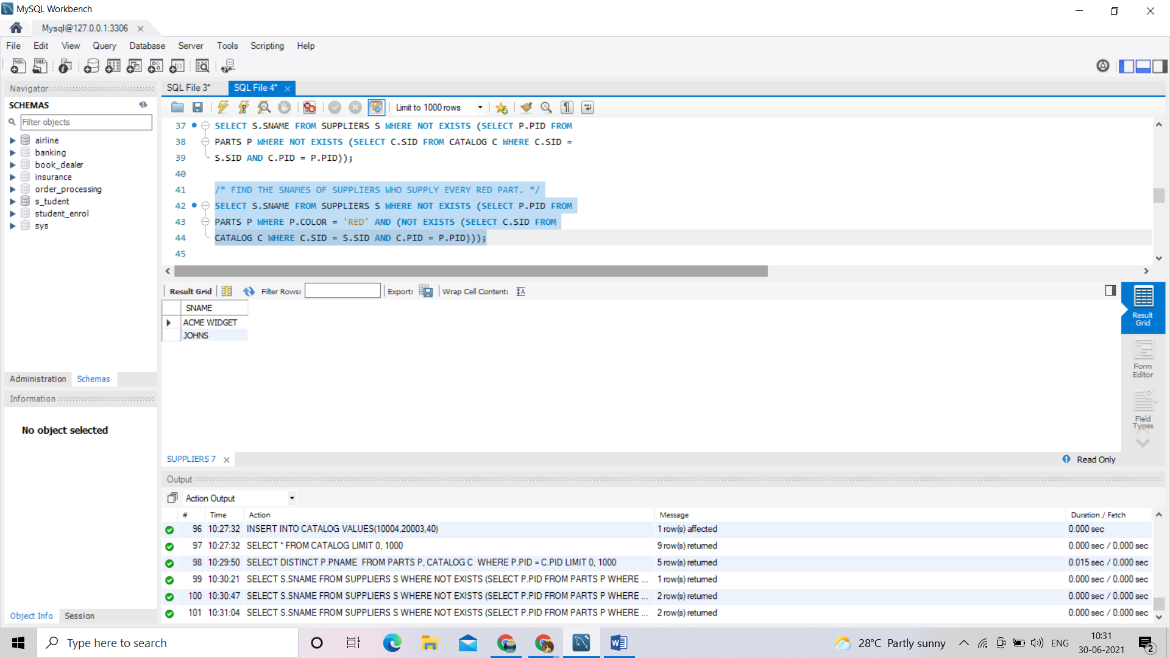

/\* 4.FIND THE PNAMES OF PARTS SUPPLIED BY ACME WIDGET SUPPLIERS AND BY NO ONE ELSE \*/

SELECT P.PNAME FROM PARTS P, CATALOG C, SUPPLIERS S WHERE P.PID

= C.PID AND C.SID = S.SID AND S.SNAME = 'ACME WIDGET' AND NOT EXISTS

(SELECT \* FROM CATALOG C1, SUPPLIERS S1 WHERE P.PID = C1.PID AND

C1.SID = S1.SID AND S1.SNAME <> 'ACME WIDGET');

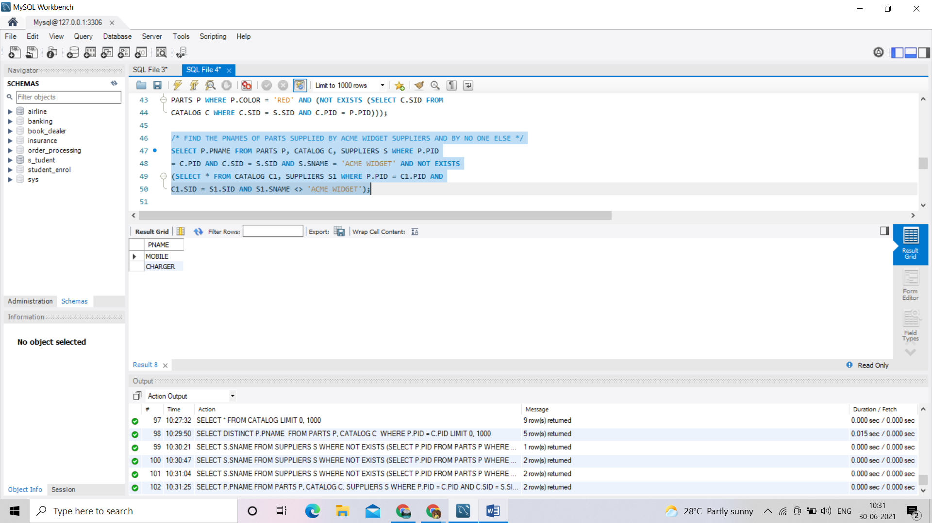

/\*5. FIND THE SIDS OF SUPPLIERS WHO CHARGE MORE FOR SOME PART THAN THE AVERAGE COST OF THAT PART (AVERAGED OVER

ALL THE SUPPLIERS WHO SUPPLY THAT PART).

\*/

SELECT DISTINCT C.SID FROM CATALOG C

WHERE C.COST > ( SELECT AVG (C1.COST)

FROM CATALOG C1

WHERE C1.PID = C.PID );

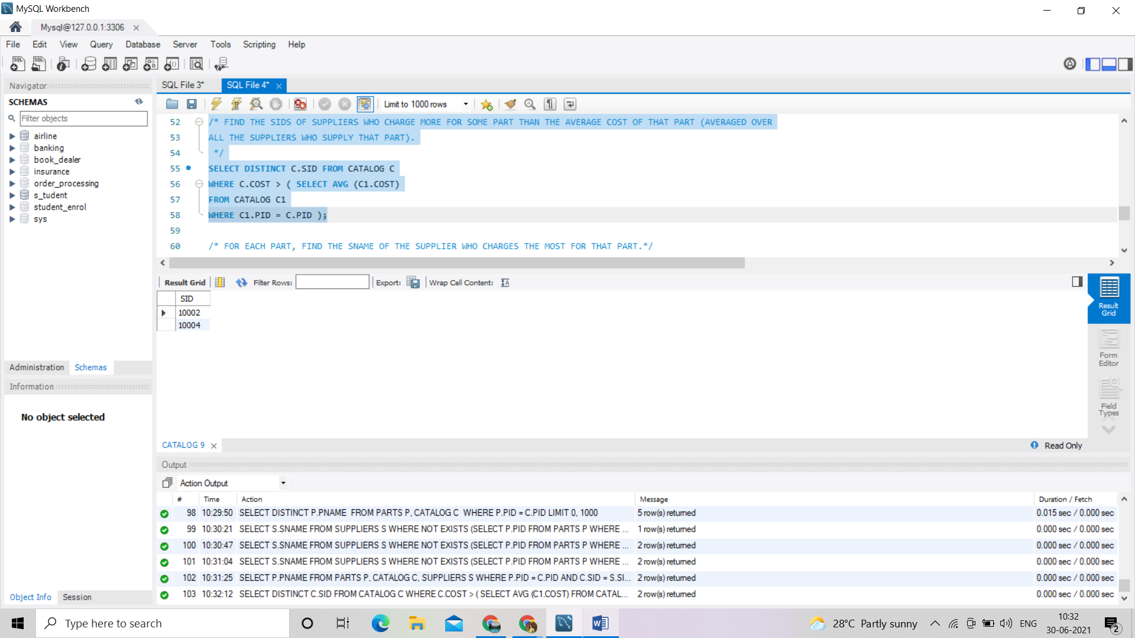

/\* 6.FOR EACH PART, FIND THE SNAME OF THE SUPPLIER WHO CHARGES THE MOST FOR THAT PART.\*/

SELECT P.PID, S.SNAME

FROM PARTS P, SUPPLIERS S, CATALOG C

WHERE C.PID = P.PID

AND C.SID = S.SID

AND C.COST = (SELECT MAX(C1.COST)

FROM CATALOG C1

WHERE C1.PID = P.PID);

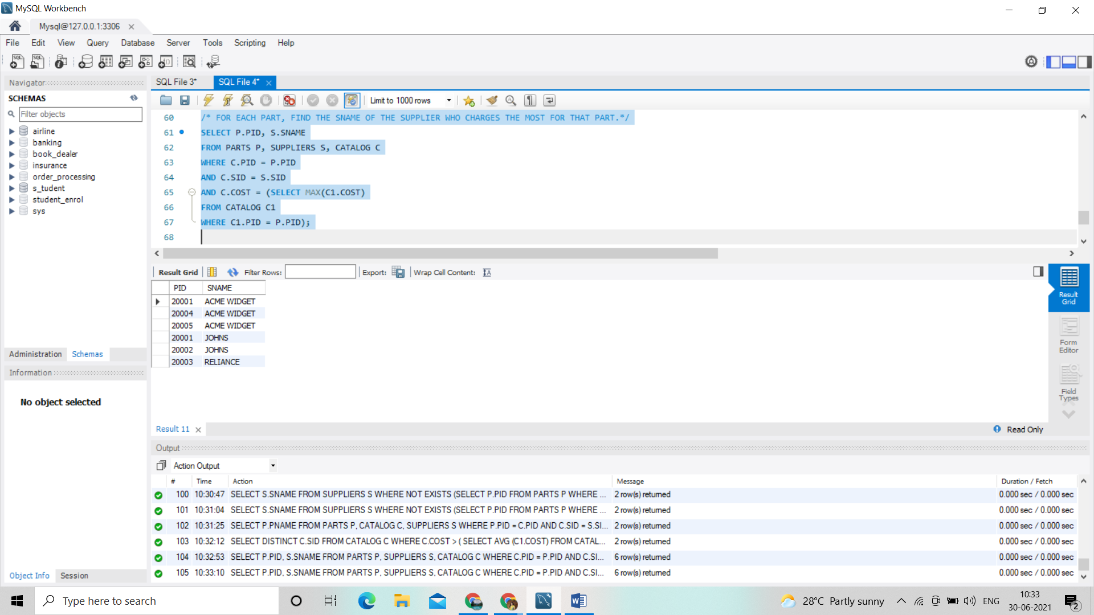

/\*7. FIND THE SIDS OF SUPPLIERS WHO SUPPLY ONLY RED PARTS.\*/

SELECT DISTINCT C.SID

FROM CATALOG C

WHERE NOT EXISTS ( SELECT \*

FROM PARTS P

WHERE P.PID = C.PID AND P.COLOR <> 'RED' );

